**SUHASITA RANI (231701013) EXPERIMENT-02**

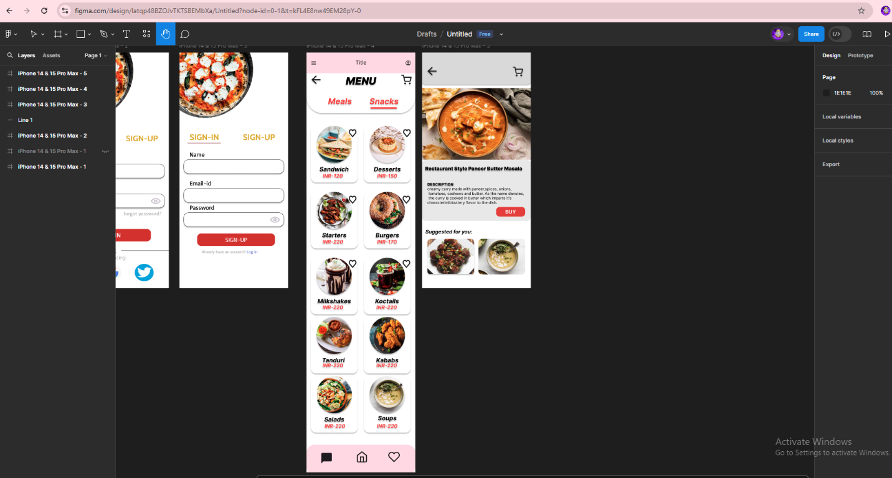

PROCEDURE:

1. Open Figma and create a new file

2. Set up frames of different screen sizes

3. Gather Resources

4. Start with outline to a low defined basic structure

5. Include all essential components like logo, prices, descriptions, suggestions etc

6. Refine the design ensuring all the elements are pixel perfect

7. Create a menu

8. Export the design assets for development

RESULT :

The experiment is done and the output is verified